**Jira Assignment 2**

**Screenshot 1: Create a single user story**

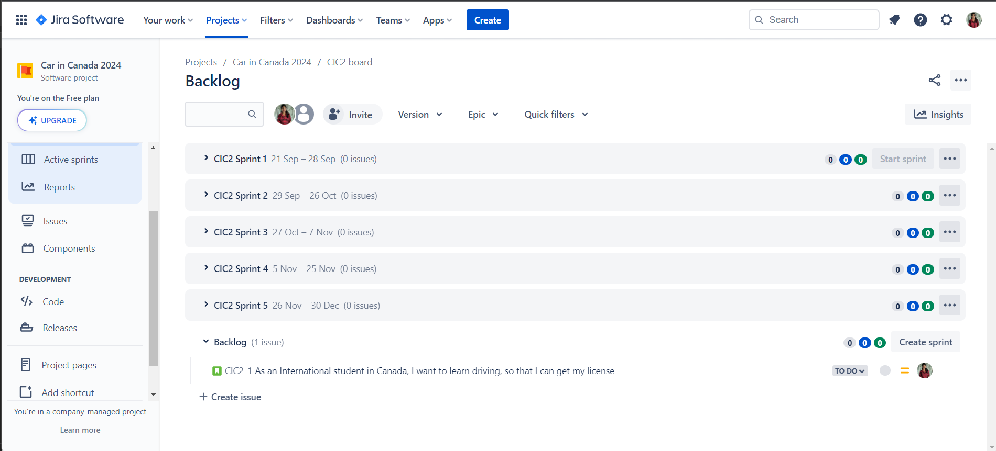

**Screenshot 2: Create atleast 2 components**

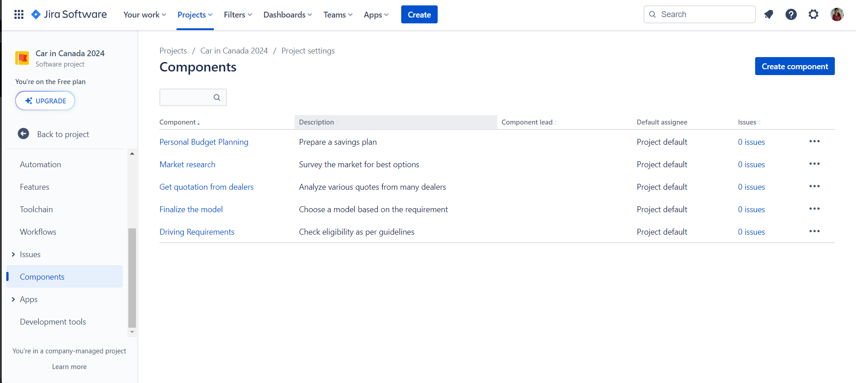

**Screenshot 3: create at least one custom field (Kano or MoSCoW), you may need to search to find what you just created**

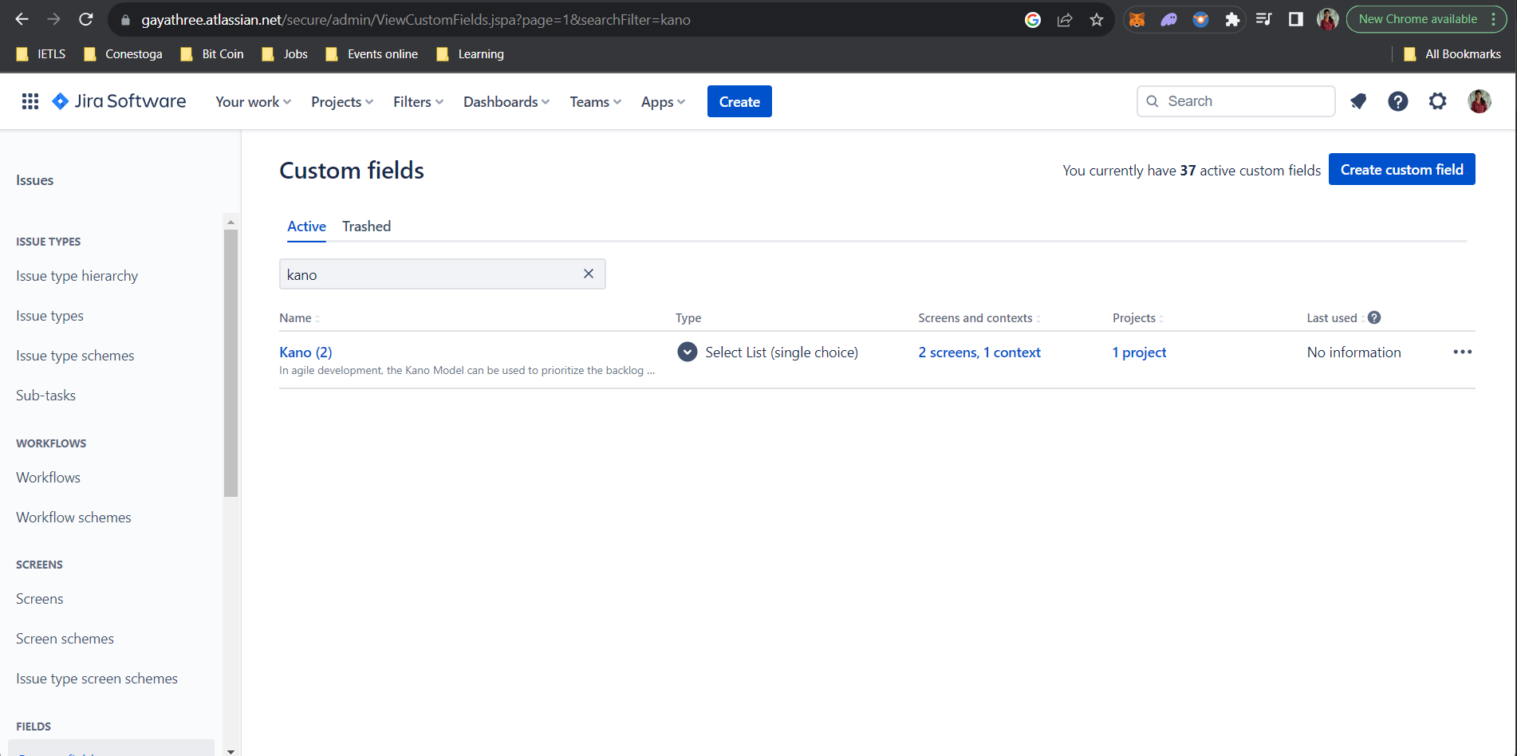

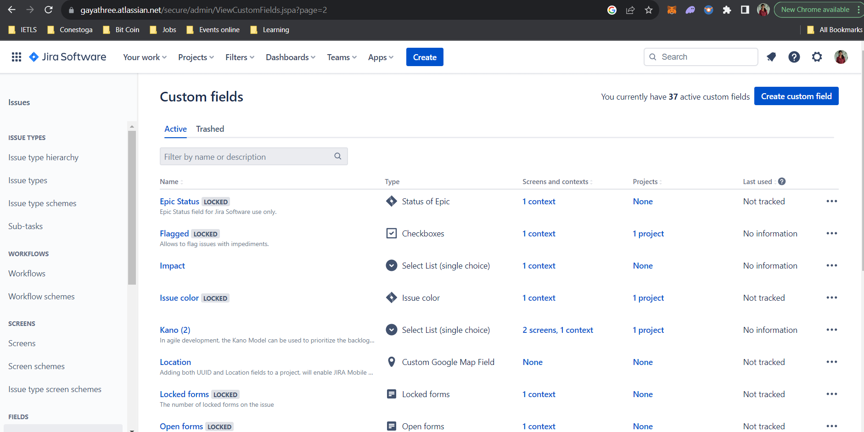

**Screenshot 4 – create at least 3 more stories, add a component and select a custom field option to all of them**

